Case 14-MEX-Maya-Jaguar-Mortar and Pestle-Classic Period-900 CE

### 

### 

(of pestle)  2.7/8" x 1.3/8" x 1.1/4"

Case No.: 14

Accession Number:

Formal Label: MEX-Maya-Jaguar-Mortar and Pestle-Classic Period-900 CE

**Display Description:**

Pestle has a floral design on top of handle

Mortar has a three dimensional carving of the head of a Jaguar and the full figure of a sloth along with scratched in panel like designs running around the sides with images of what appear to be flora and landscapes. Rim decorated with scratched in repeating design of stylized seeds.

LC Classification:

Date or Time Horizon:

Geographical Area:

Map:

GPS Coordinates:

Cultural Affiliation:

Medium:

**Dimensions**:   
**Weight:**

**Provenance**:

**Condition:**

**Discussion:**

**References**

### Delivery package 1 of 1

Estimated delivery Wednesday, Jan 20, 2016 - Saturday, Jan 23, 2016

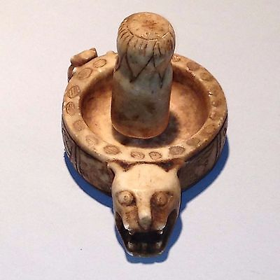

#### [Antique South American Limestone Mortar & Pestle Jaguar & Sloth Effigy](http://www.ebay.com/itm/231806972263)

|  |  |
| --- | --- |
| Item price | $128.00 |
| Quantity | 1 |
| Item number | 231806972263 |
| Shipping service | USPS Priority Mail Medium Flat Rate Box |

## Shipping address

Ralph J Coffman Jr

149 Atlantic Ave

Swampscott MA 01907-2427

United States

## Order total

|  |  |
| --- | --- |
| Subtotal | $782.50 |
| Shipping | $32.99 |

**Total**

$815.49

Order placed on

Monday, Jan 18, 2016

Payment method

PayPal

Payment date

Monday, Jan 18, 2016